### Statistical Machine Learning Approaches to

### Liver Disease Prediction

**Team ID: PNT2022TMID08311**

**Faculty Mentor Team Leader:** Kavuri Swathi

T.Geetha **Team Member:** Jasthi Jyothi

**TeamMember:**Karumudi Meghana

**TeamMember:**Biridepalli Mounisha

### Exploratory Data Analysis

The exploratory data analysis (EDA) notebook is designed to assist you with discovering patterns in data, checking data sanity, and summarizing the relevant data for predictive models.

The EDA notebook example was optimized with web-based data in mind and consists of two parts. Part one starts with using Query Service to view trends and data snapshots. Next, with a goal in mind for exploratory data analysis, the data is aggregated at the profile and visitor level.

Part two starts by performing descriptive analysis on aggregated data using Python libraries. This notebook showcases visualizations such as histograms, scatter plots, box plots, and a correlation matrix to derive actionable insights used to determine which features are most likely to be helpful in predicting a goal.



**head()** :To check the first five rows of the dataset, we have a function called **head( ).**

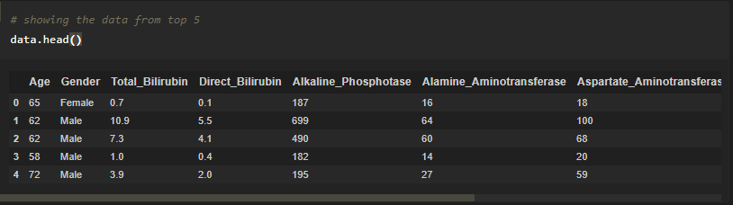

**Tail():** To check the last five rows of the dataset, we have a function called **tail().**

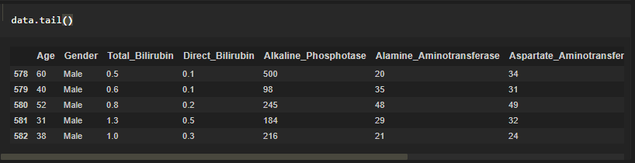

Will see how our dataset is, by using the info() method.

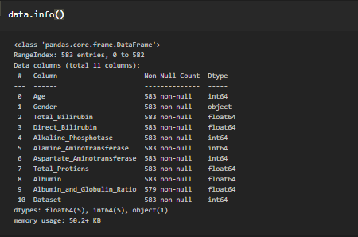

**describe():** functions are used to compute values like count, mean, standard deviation and IQR(Inter Quantile Ranges) and give a summary of numeric type data.

https://lh5.googleusercontent.com/Mquoi2KA_ZyIfd3rj8YdDDp2hDf155BAPe5R7JZ7ZHXVsgbIVpRleK7ZoodBQaaNdx_be3j_moF_cggEObD1811rhFc9Z0pfUGnX69tbOouqA7CDB-OkdS6ObQLsFeV_FwgTUBI=s1600

